**JETTY**

**Jetty** is a lightweight, open-source web server and servlet container written in Java. It is widely used for deploying web applications, web services, and other Java-based applications.

Jetty is known for its:  
**High performance**: It can handle a high volume of requests and transactions.  
**Scalability**: It can be easily scaled to handle increased load.  
**Portability**: It runs on a variety of platforms, including Windows, Linux, macOS, and Unix.  
**Embeddability**: It can be easily embedded within other applications, making it ideal for microservices architectures.

Here are some of the popular applications of Jetty:  
**Web applications**: Serving web pages and static content.  
**RESTful APIs**: Exposing data and services through APIs.  
**Microservices**: Building small, independent services that communicate with each other.  
**Embedded applications**: Integrating web functionality into non-web applications.It is developed by the Eclipse Foundation and is often used to deploy Java web applications.

**Apache Procrun, short for Apache Process Run,** is a set of utilities provided by the Apache Commons Daemon project. Procrun simplifies the process of running Java applications as Windows services. It provides a way to register, manage, and run Java applications in the background on Windows operating systems.

============================================================================

**POC Requirement**: Running Jetty as a Windows service using Apache Procrun without using the Windows service wrapper , but it requires a bit of manual configuration.

Here are the general steps you can follow:

Prerequisites:

1. Java Installation:  
Make sure Java is installed on your system, and the JAVA_HOME environment variable is set.  
Download the java on windows system.

<https://www.oracle.com/java/technologies/javase/jdk11-archive-downloads.html>

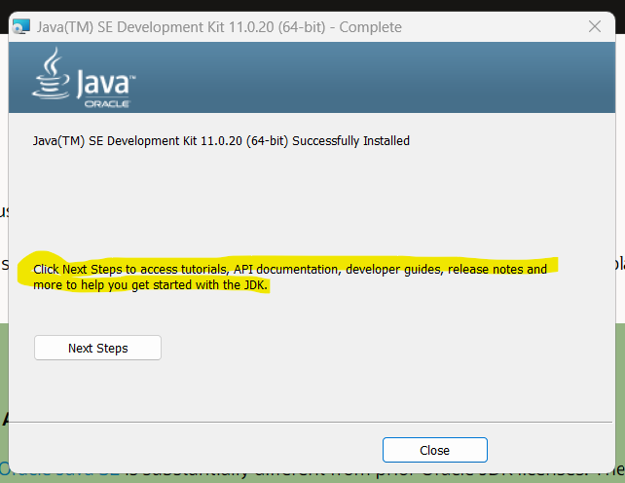

2. Jetty Download  
Download and install Jetty on your machine. You can get the latest distribution from the official Jetty website.

<https://eclipse.dev/jetty/download.php>

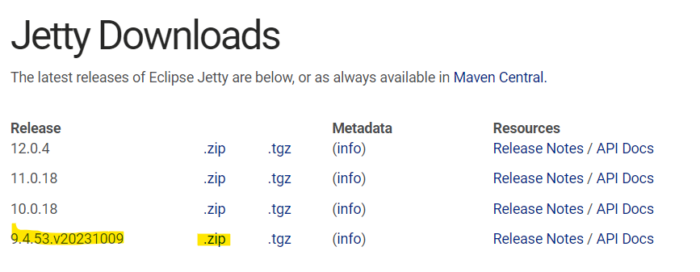

3. Apache procrun Download:

Download the Apache Procrun binaries. You can find them on the Apache Commons Daemon website.Procrun is a set of applications for running Java applications as Windows services without the need for a console terminal.

<https://archive.apache.org/dist/commons/daemon/binaries/>

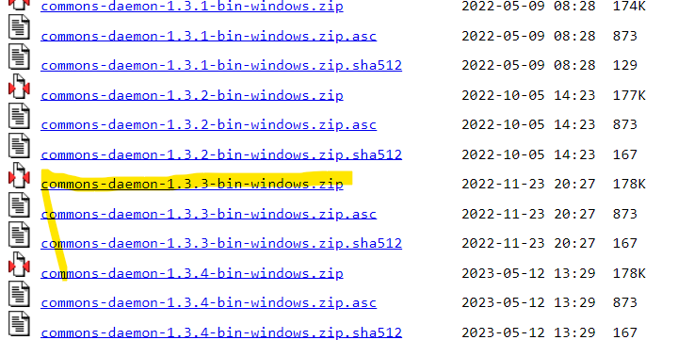

Once 2nd and 3rd steps finishes then extract the zip file to preferable location after creating new folders.

-extract jetty in jetty distribution 9.4.53 folder.

- extract all in apacheprocrun.

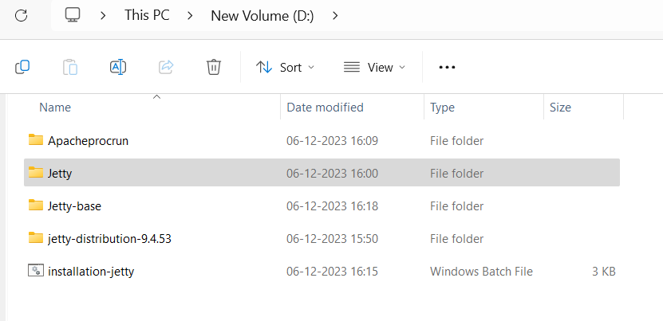

4. Inside jetty base folder create 2 folders (logs and temp).https://xy2401.com/local-docs/java/jetty.9.4.24.v20191120/startup-windows-service.html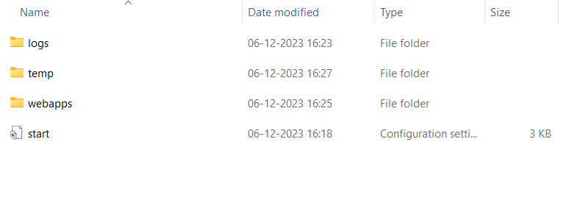

5. Open below link and copy the example of bat file in notepad .

<https://xy2401.com/local-docs/java/jetty.9.4.24.v20191120/startup-windows-service.html>

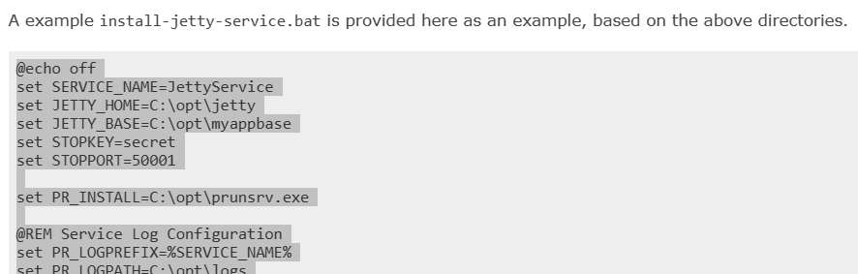

and do the changes as highlighted in the below snapshot.

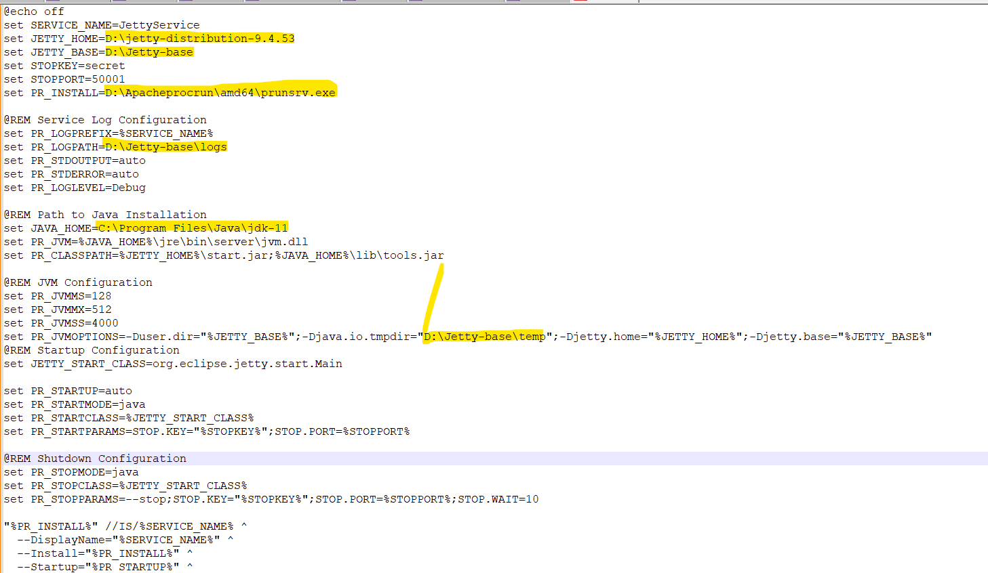

6. D:\Jetty-base>java -jar ..\jetty-distribution-9.4.53\start.jar --add-to-start=deploy,http,console-capture

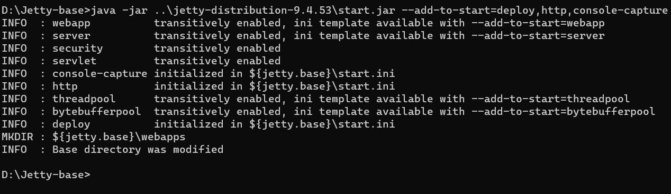

Then came back to D drive and install jetty.bat.

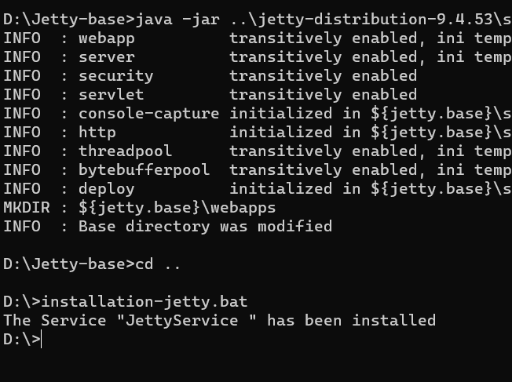

6. Now in search bar look for services and under services you will find jettyservice. if we don't install the jetty.bat file then it (jettyservice) won't appear here.

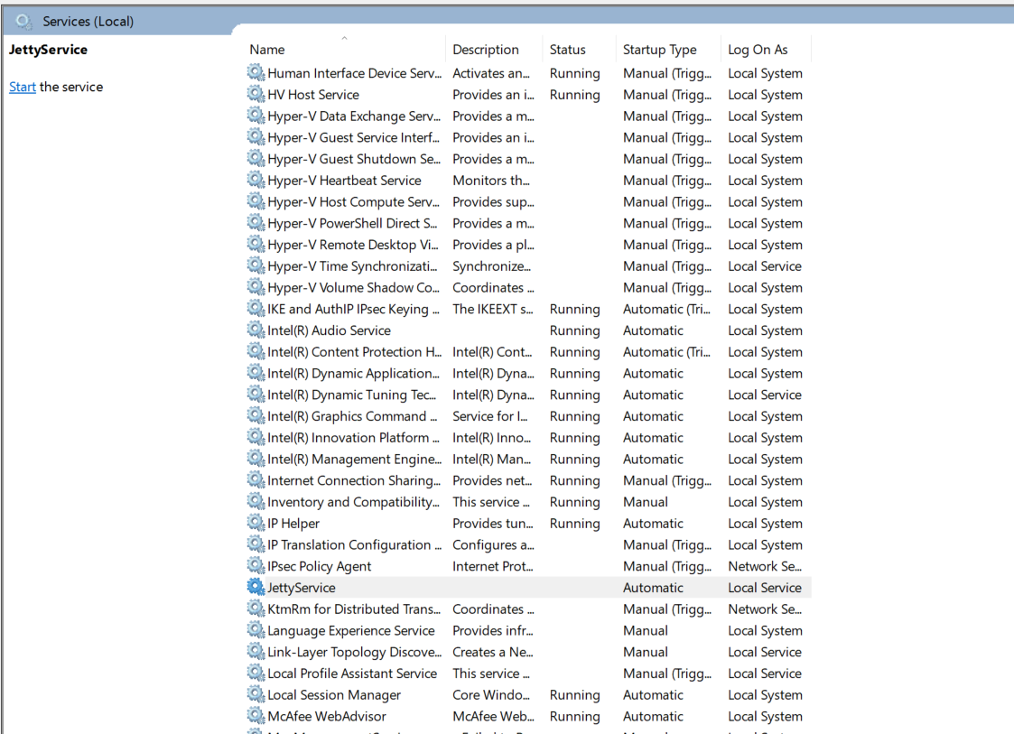

after starting

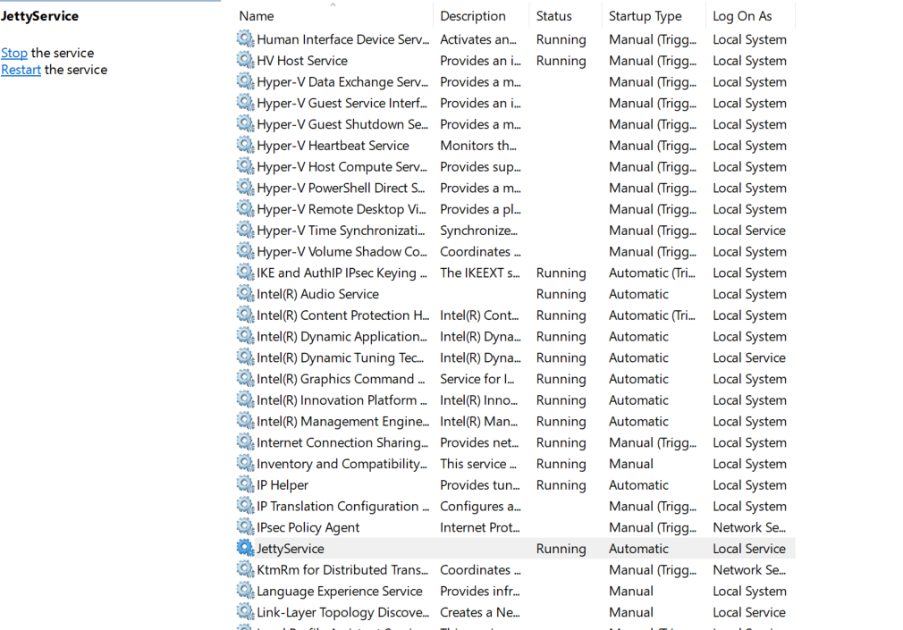

7. Verify: Open a web browser and navigate to <http://localhost:8080> (or the configured port) to ensure that Jetty is running.

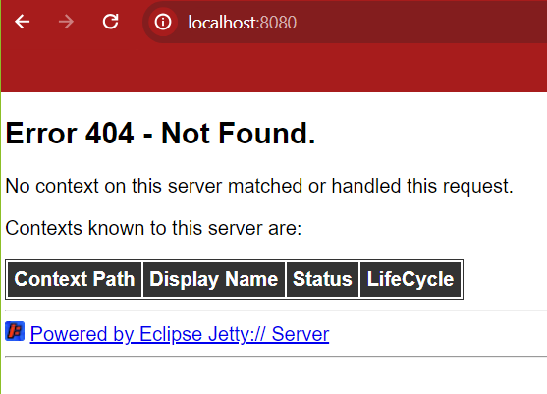

8. Now create a folder called webapps inside Jetty-base folder and put a folder (helloWorld) and inside it put a notepad doc (which contains the code)



Sample code:

<!DOCTYPE html>  
<html>  
 <head>  
 <title>Testing Jetty as windows service</title>  
 </head>  
 <body>  
 <h1>Happy Coding</h1>  
 <p>Hello world!</p>  
 </body>  
</html>

=> Now, refresh it.

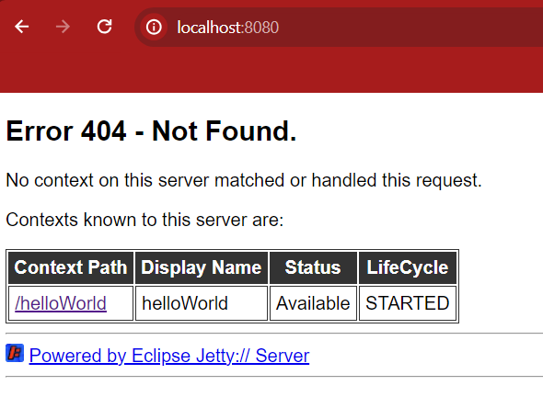

=> click on the context path, you will find below output.

